WARP 10
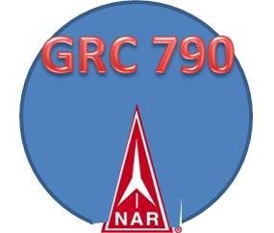
Newsletter #8 June 2017
Club Report

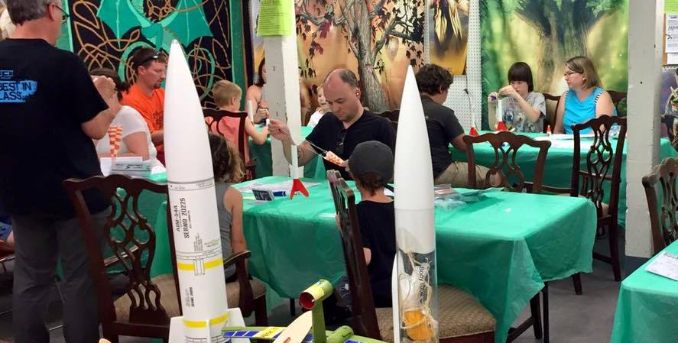The latest Rocket build at the Hood River Hobby Shop on June 24th was well attended. Thank you to everyone who attended the event. The launch convened at the Westside Elementary school at 1 pm. Almost all of the rockets that were launched were recovered. One rocket did land on the roof of one of the small school trailer houses. Even though we would always like to get every rocket returned, it is safer to wait and if the rocket is not able to be returned, it is far less hazardous to build another one instead of risking injury attempting to climb up on the roof.
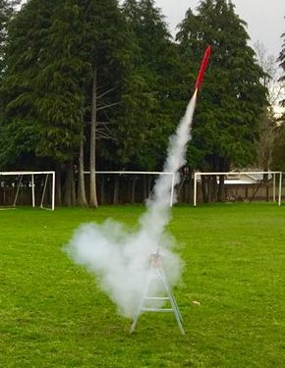
Every person that received this newsletter is a Gorge Rocket Club member and will receive a Gorge Rocket Club membership card as proof. Becoming a Gorge Rocket Club member gives you the privilege of being able to launch your rockets at all of the club launch events.
At least five of the Gorge Rocket Club members are National Association of Rocketry (NAR) members. This is helpful with regards to having liability insurance for the club launches. If you would like to become a NAR member please do. It is not mandatory but highly encouraged. When you become a NAR member you are covered with a 5 million dollar liability insurance. You will also receive a Sport Rocketry magazine which is bi-monthly.
http://www.nar.org/join-nar/
We have several launches scheduled for the rest of 2017. Most of them will be at the WyEast middle school football field. We have a 1,500 foot waiver which allows us to fly up to a mid class G motor.
One of the upcoming launches which is on July 29th will be at Westside due to the fair going on at WyEast during that time.
Here are all of the current dates:
July 15 9 am to 12 pm at WyEast Middle School
July 29 9 am to 12 pm at -West side Elementary-
Aug 12 9 am to 12 pm at WyEast Middle School
Aug 26 9 am to 12 pm at WyEast Middle School
Sept 16 9 am to 12 pm at WyEast Middle School
Sept 30 9 am to 12 pm at WyEast Middle School
October 14th, 9 am to 12 pm at WyEast Middle School
October 28th , 9 am to 12 pm at WyEast Middle School
November 4th , 9 am to 12 pm at WyEast Middle School
November 18th, 9 am to 12 pm at WyEast Middle School
December 2nd, 9 am to 12 pm at WyEast Middle School
December 16th 9 am to 12 pm at WyEast Middle School
The hobby of rocketry has been around since 1957.
October 8, 1957 – The Model Missile Association incorporated under the laws of the state of Colorado.
January 3rd, 1958 – The first meeting of the Model Missile Association took place in the Hammond Organ Studio on Colorado Boulevard, Denver, Colorado. One hundred fifty (150) people attended and one hundred (100) signed as Charter Members.
February 1, 1958 – The first issue of THE MODEL ROCKETEER was published.
July 1958 – Demonstrations and discussions were held with the Academy of Model Aeronautics at Glenview Naval Air Station, Illinois regarding possible AMA model rocket competition events.
August 12th, 1958 – William S. Roe gets Colorado Springs, Colorado to adopt the nation’s first permissive model rocket law.
September 6th, 1958 – The second official NAR model rocket range opened in Memorial Park, Colorado Springs with local USAF recognition.
September 18th, 1958 – The Mile-High section, Denver, Colorado was granted the first section charter.
October 25th, 1958 – Name of organization officially changed to National Association of Rocketry.
April 12-18, 1959 – National Association of Rocketry was represented at the First World Congress of Flight, Las Vegas, Nevada. Demonstrations were flown and initial contact with National Aeronautics Association took place.
May 16th, 1959 – The world’s first model rocket competition was sanctioned by NAR at Green Mountain Proving Ground, Denver, Colorado.
July 16 – 19, 1959 –NARAM-1, Hogback Rocket Range, Denver, Colorado. G. H. Stine, Contest Director. Norman Mains, Jr. is first national champion.
July 1st, 1960 – NAR Headquarters moves to 11 West 42nd Street, New York, New York.
July, 1960 – The NAR teams demonstrate at the Boy Scout Jamboree, Colorado Springs, Colorado.
August 18-21, 1960 – NARAM -2, Peak City Rocket Range, Colorado Springs, Colorado. W. S. Roe, Contest Director.
April 3rd, 1961 – The NAR becomes an affiliate of National Aeronautics Association
July 3rd, 1961 – United States Airforce endorses model rocketry and names NAR as USAF official organization for the hobby.
July 16th, 1961 – The first USAF model rocketry competition, Langley Air Force Base, Virginia.
August 17-21, 1961 – NARAM 3, Hogback Rocket Range, Denver, Colorado. J. D. Hitch, Contest Director.
August 23-26, 1962 – NARAM 4, U.S. Air Force Academy, Colorado Springs, Colorado. Vernon Van Vonderen, Contest Director.
November 24th, 1962 – Federation Aeronautique Internationale officially recognizes model rocketry as an international aeromodelling sport.
March 14th, 1963 – Federal Aviation Agency exempts model rocketry from its control.
May 1st, 1963 – National Association of Rocketry headquarters moves to Stamford Museum and Nature Center, Stamford, Connecticut.
June 30th, 1963 – The state of Connecticut adopts first permissive state model rocketry law.
August 8th, 1963 – The Internal Revenue Service recognizes NAR as a non-profit educational and charitable organization.
August 22-25, 1963 – NARAM-5, Hanscom Field, Bedford, Massachusetts. M. P. Wilder, Contest Director.
August 18-22, 1964 – NARAM-6, NASA Wallops Station, Virginia. W. B. Rich, Contest Director.
September 1st, 1964 – The NAR headquarters moves to 1025 Connecticut Avenue, N. W. Washington, DC with James F. Kukowski as Executive Director.
November 21, 1964 – Federation Aeronautique Internationale adopts provisional model rocket sporting code based on NAR rules.
January 1, 1965 – NAR members get liability insurance as part of their membership.
August 18-21, 1965 –NARAM-7, Aberdeen Proving Ground, Maryland. Howard Galloway, Contest Director.
March 11-13, 1966 – The first NAR Mid-Winter convention was held in Pittsburgh, Pennsylvania.
May 28-29, 1966 – The first International Model Rocket Competition was held in Dubnica nad Vahem, Czechoslovakia. The NAR team fielded.
August 16-19, 1966 – NARAM-8, Clinton County Air Force Base, Wilmington, Ohio. G. H. Stine pro-tem Contest Director due to overseas assignment of Captain William B. Barnitz.
November 4th, 1966 – Federation Aeronautique Internationale adopts official model rocket sporting code.
January 1, 1967 – THE MODEL ROCKETEER incorporated into American Modeler (American Aircraft Modeler)magazine which is monthly to all NAR members.
May 17, 1967 – National Fire Protection Association adopts tentative Uniform Code for model rocketry in Boston Massachusetts.
August 10, 1967 – American Institute of Aeronautics and Astronautics endorses model rocketry.
August 15-18, 1967 – NARAM-9, Mankato State College, Mankato, Minnesota. Dr. Ellsworth B. Beetch, Contest Director.
Today the hobby is thriving. There is currently an event that takes place every year across the globe that is intended for students from the 7th to 12th grade school level called the Team America Rocket Challenge. So far it has been active for 15 years: http://rocketcontest.org/
Every year the rules change. The objective of the contest is to help inspire students who are interested in engineering or aerospace to learn to work as a team, compete and share ideas.
For the past two years, the US schools that won and were able to compete in Europe against the European schools have returned home as the champions. This may be something of interest to local students here. If they are, they should bring this idea up with their science teachers. This is a great way to inspire others in the field of engineering and aviation or more.
Also did you know that there is an Olympic style event that occurs every two years in rocketry? It is called the World Space Modeling Championship.
http://worldrocket2016.frms.ua/en/
In 2016 it was in the Ukraine. The next WSMC will be in 2018.
If anyone is planning to go up to the Seattle Washington area during the summer time The Museum of Flight has a permanent display of rocketry. They have the collections from Vern Estes and the founder of Centuri as a permanent fixture there. It is definitely worth seeing. Shuttle Astronaut Jay Apt was interested in rocketry. On one of his shuttle missions they took up to space a model rocket by Vern Estes. That rocket is now at the museum.
http://www.gorgerocketclub.com/wp-content/uploads/2016/09/May_June-issue-2017.pdf
Please feel free to contact me anytime with questions about the hobby or other aspects at Thompsonje@gmail.com

