WARP-10

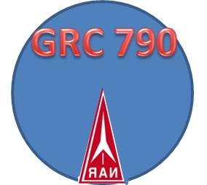
GRC 790 Newsletter 2
First Official Club Launch Report
By John Thompson (Club supporting Advisor)
The first Club launch for the GRC 790 club went well minus a minor hiccup with the football field sprinkler system. All in all for the first official club launch it went smoothly.
I arrived at the field about thirty minutes before the official launch time of 9 am. Daniel Peirce showed up soon after with his son and helped get the launch pad setup and also wore the nice NAR Safety vest which was graciously provided by NAR. I also setup the NAR Banner that was provided from the organization to help promote the club and organization.
Zed Ruhlen from Hood River Hobbies showed up soon after with a few rockets to launch. His children and wife showed up soon after. We had a few other participants arrive and watch as well as launch a few Estes rockets.
We circulated low powered flight cards for everyone to fill out and it was a good way of keeping track of who launched what at the event.
Daniel Peirce had the most launches out of the day with a total of 15 flights. 12 were recorded and a few were missed and that was due to a slight issue when the football field sprinklers came on at 10 am unexpectedly. The blank flight card forms became wet and needed time to dry. Each rocket was inspected prior to flight and once the flight cards were dry we resumed filling them out.
Daniel Peirce had a beautiful collection of some of the latest rockets sold from Estes as well as a 1974 classic from Estes.
Daniel launched the Estes Honest John first with a D12-3. The first igniter melted to the igniter plug. The second attempted worked. The parachute became tangled during the recovery portion and descended faster than planned but no damage to the rocket was observed other than needing a new parachute.
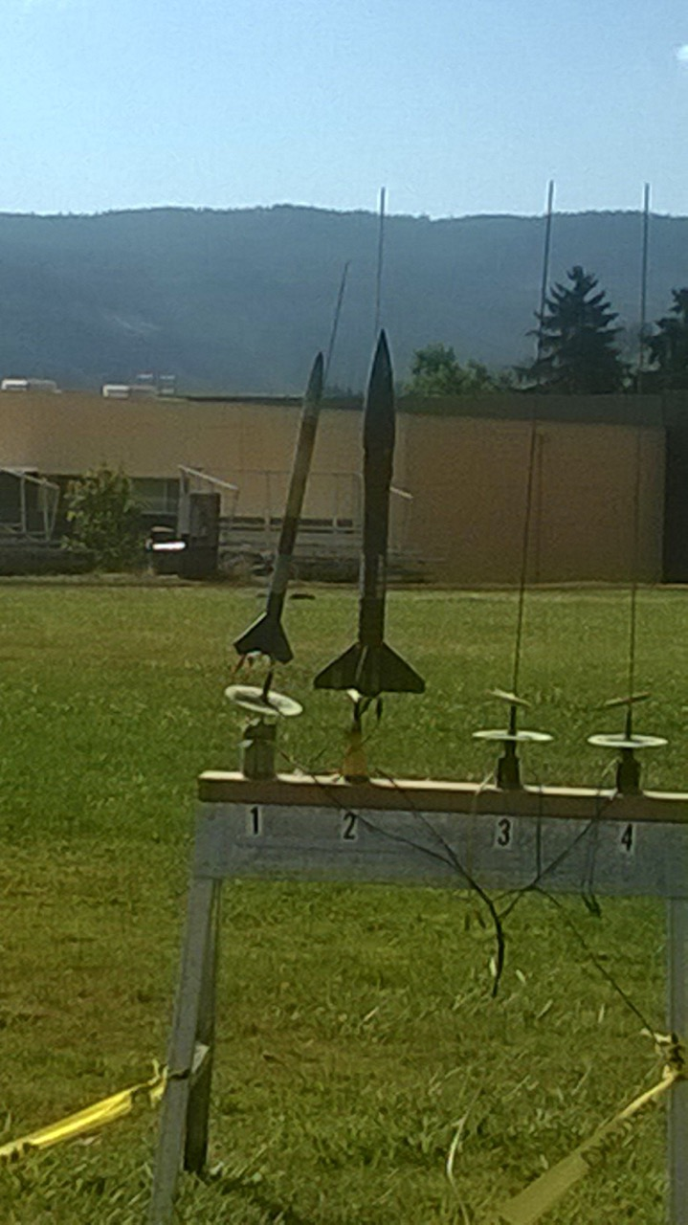
Daniel also launched the following rockets:
- Flis-kits Saturn 1B on an Estes A3-4t (successful flight and recovery)
- 1976 Classic Estes Alien Invader on an Estes B6-4 (Good flight and recovery, one of the leg staff broke on landing, however it is repairable and will fly again)
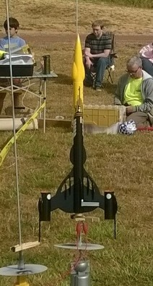
- Estes AMRAAM on an Estes C6-3 (separation during recovery deployment. Nose cone and parachute found together and the main body was found after launch day. Minor damage, repairable and will fly again)
- Estes Bandit with Lego passenger in the clear payload section: Launched twice with Estes B6-4. Perfect launch and recovery.
- Estes QCC Explorer: Launched with an Estes D12-3. Picture perfect launch and recovery.
- Estes Renegade kit: Launched on a C11-3. Great flight and recovery.
- Estes Black Star Voyager: This is a skill level 5 rocket and is beautiful. This rocket went up on an Estes D12-3. It was a beautiful first flight. (I will definitely get one of these kits as well as the Estes QCC Explorer)
- Estes Mini Honest John: Launched on an Estes A3-4T with streamer recover. Picture perfect flight and recovery.
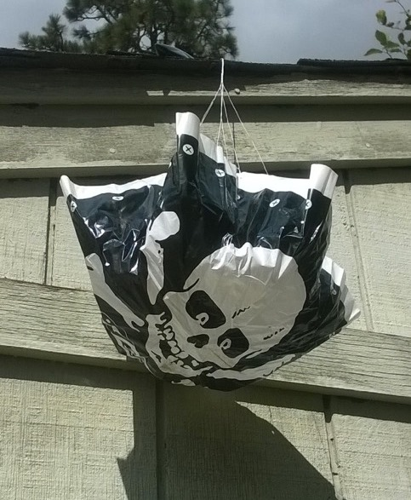

****We quickly shifted our gear to the left and continued to launch.***
I called the point of contact for the permit that I had for being authorized to launch at the field and inquired as to how to get the sprinkler system turned off. She did now know but was able to call the grounds keeper. The grounds keeper quickly called me back and informed me that they were not programmed to go on. About ten minutes later the sprinkler system was off and we continued to launch rockets for another two hours. We had authorization to fly from the football field from 9am to 12pm so I was not going to let a sprinkler system shut us down ☺
Zed Ruhlen launched the Estes Red “Crayon Rocket” twice on an Estes C6-5 and once on a C6-3 motor and all three were picture perfect flights. He did a smart thing by cutting a hole (spill hole)in the parachute to help prevent the rocket from drifting too far away since the Gorge area is known for its inconsistent breezes. I placed a few wind pennants up in order to help keep an observation of the wind directions. The biggest breeze we were experiencing was at about 14 miles per hour. We never reached the limit of the 20 mile per hour winds. Zeds rocket flight all landed very close to the launch pad area.
Xander Thompson launched his Estes Purple “Crayon Rocket”. The first launch was with a B6-4 and landed pretty close to the pad. The second launch was on an Estes C6-3. His parachute did not have a spill hole. On the second flight it went quite high and during the parachute recovery and descent, it acquired a nice thermal and drifted out of the football field into the recreational vehicle camping area. Zeds young sons happily ventured out and recovered the Purple Crayon rocket and it was completely intact and ready to be launched another day. The one fun thing about this hobby and technology today, is that there are software programs that you can find on line for a lot of fun projects. There is one on the rocket reviews website that is helpful on calculating the correct sized parachute for your rocket.
http://www.rocketreviews.com/parachute-size-calculator.html
I do not know if there is one for calculating the correct size of a spill hole. If someone finds one for that project, please let me know☺
I had a box full of rockets myself to launch. I had recently built a fun and ingenious kit from a company called Oddl Rockets. The rocket is a skill level 2 kit, however it could easily be thought of as a skill level 3. It is called the “Break Away” rocket. It does not have streamer or parachute recovery. It goes up on 18mm sized rocket motors and separates into six sections that are all linked together with a fire proof Kevlar line. It is a real eye catcher and I like its simplicity. It does take time to assemble.
The owner of Oddl Rockets is Chris Michielssen. He sells his kits through several vendors (JonRocket, Apogee and Sirius Rocketry). Chris has a neat website and also has a flying pig rocket called “The Pigasus” and another cute rocket of an alien called “The little Green Man”.
http://oddlrockets.blogspot.com/p/kits.html
It would be cool to see some of these kits at the Hood River Hobbies Shop.
I launched the Break Away rocket three times. Once on an Estes A8-5, then with a Estes B6-2, and then a Quest C6-0. All three flights were successful.
The second rocket I launched was a small square rocket from a company called New Way Space Models. The kit is named “Dare To Be Square”. They are sold on Ebay and a couple of online vendors.
http://www.newwayspacemodels.com/index.php?option=com_content&view=article&id=71&Itemid=1
It is a tumble recovery rocket and fun to watch.
The third rocket I launched was the “Acme Spitfire” rocket from Flis Kits. I bought this rocket a while back from Hood River Hobbies. This is a fun rocket and I plan on building another one with a Steam Punk design. http://www.fliskits.com/products/rocketkits/kit_detail/acme.htm
For the first official launch as a club, I think all in all it went well.
I look forward to the next launch day which will be on a Saturday (August 27th, 2016) on the middle soccer field at WyEast from 9am-12pm.
I look forward to seeing fellow rocketeers there☺
Video clips of launches:
http://www.gorgerocketclub.com/wp_20160807_011/
http://www.gorgerocketclub.com/2016/08/08/acme-spitfire-launched-on-a-c11-3/

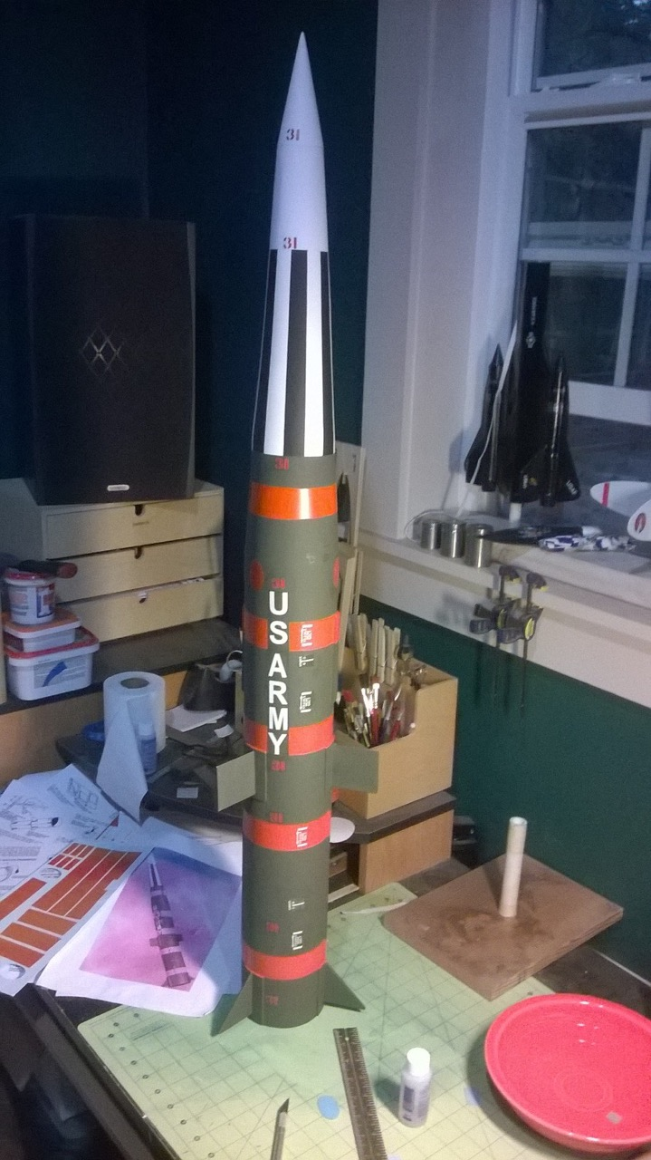
Daniel Peirce built this beautiful Pershing 1A rocket from the “Launch Pad” company.

