December club Launch Report:
The weather was calm with a slight overcast. Jim Reed and his grandson Harrison who attended the Thanksgiving rocket build made it out to the launch area at 9 am. Harrison launched his Alpha rocket twice on Estes A8-3 motors. Harrison built the Alpha rocket at the Hood River Hobby Shop .
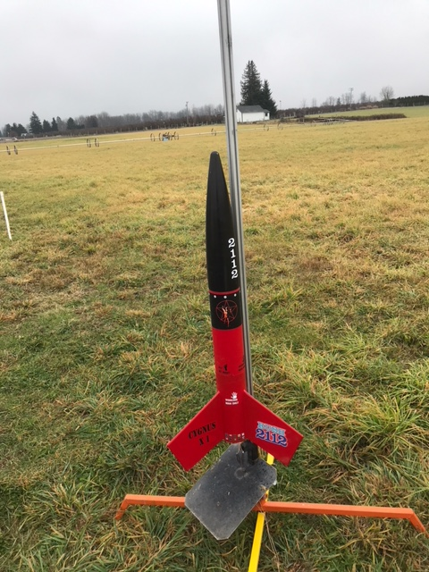
Daniel Peirce and his son as well as Scott Trousdell and his two sons were in attendance at the launch. It was a good turnout. Daniel brought out this biggest selection of rockets to launch and each of his rockets launched were successful and recovered. Ian Trousdell brought out two rockets that launched and came back safely.
Zed and his two boys showed up too at the launch☺
The low clouds made some of the launches look interesting. The smoke would linger on the ground from the exhaust for a while after liftoff.
The field is a new area where we have launched three times before. We were able to get the two land owners approval and the National Association of Rocketry insurance representative provided the two sites with the endorsed 5 million dollar liability insurance data so we can launch from the site. Even with the insurance this does not mean we can launch anything in an unsafe manner. SAFETY is always paramount and followed in order to make sure all in attendance are safe and we conduct the operations in a professional manner at all times. One unsafe act could prevent us from launching at the site.
I had brought out two rockets. One was a three inch diameter rocket with a 3D printed tail cone and nose cone with an altimeter payload compartment. The 3D printed parts were made by The Rosenfield Aerospace Store: (https://www.rosenfieldaerospace.com/ ) He is the brother of Gary Rosenfield who is the founder of Aerotech. I was planning to launch the rocket on a 38mm H-130 reload motor, however; the clouds were quite low and prevented a guarantee of good visibility so I will schedule to launch it on another day when the sky are better. The other rocket was a fun Fliskit rocket called the UFFO which stand for “Unidentified Flying Foam Object”. It went up on a Quest C6-0. It was entertaining to see eventhough it did not go up very high. The Quest C6-0 motors do not perform as reliably as the Estes C6-0 so the next flight will be up on an Estes C6-0 with hopefully better flight characteristics.
The highest launch of the day was 912 feet by Daniel with his Maxi Der-Red Max on a G-75 Metal Storm motor. We need to stock up on those motors. They are quite a crowd pleaser.
Below are Google Drive links of videos and images from the days launch:
https://drive.google.com/file/d/1e4EblMNStom0oi_zvysKPWo5eoLr5ljH/view?usp=sharing
https://drive.google.com/file/d/1geR6BpN-UwZR1yinr0DJVPRd8m0QW58i/view?usp=sharing
https://drive.google.com/file/d/1cbqqt0xyc-6DRIpdG6deCeqesxOkN2un/view?usp=sharing
https://drive.google.com/file/d/1Ko8scWKR4QTVM6cN3PL46bh07TKlNEX5/view?usp=sharing
Photo: https://drive.google.com/file/d/13z5D5xikqgTUAR5iWMJ9hkIxu3MRSksA/view?usp=sharing
https://drive.google.com/file/d/1HCTCMfyJgAlMVbVE2j7ucwW1ZG4I6xIX/view?usp=sharing

