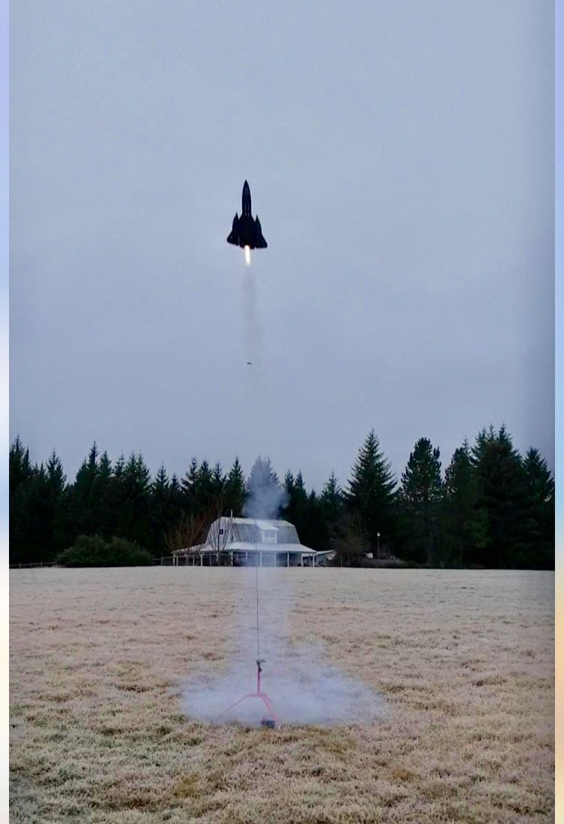“Happy Holidays,”

We had a cold but not windy rocket launch day here on December 22nd, 2018 and had some memorable flights.

The first launch was of the classic Hobby lab SR-71 boost glider. The liftoff was awesome. It is a good thing that Vernon took some memorable photos, because the blow molded Styrofoam glider disintegrated during its upward ascent. The E15-4W worked perfectly. It was a great way to go if it was going to come apart. ☺

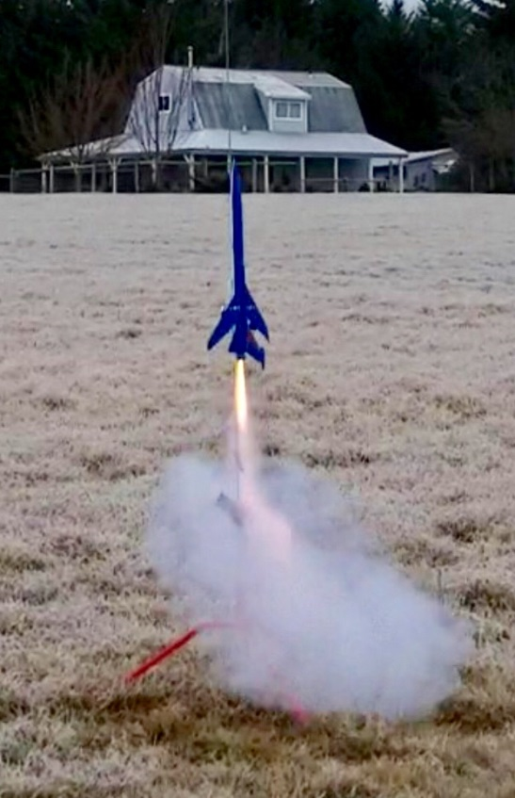The second launch was of a new Estes rocket kit that resembles a lot of the SNARK Cruise missile. The rocket went up on a D12-5. It did a nice roll upwards straight and true. The delay should have been a 3 second delay instead of the 5 second delay. The parachute did deploy and the rocket recovered just in the nick of time. The rocket kit is called “Conquest” catalog number 7230. The kit was built by Don Buchanan. I have the kit built as well and will have to bring it to our next clubs launch so we can have a drag race.

Speaking of drag races, I did bring a cool skill level 5 rocket kit by Estes called the Dark Star Voyager. Don Buchanan had his Dark Star kit as well. We did a drag race utilizing Aerotech E15-4Ws. I think that motor is about as powerful as you can go with that kit before it would come apart. It was a great final flight for that cold day.

I hope you had a nice and relaxing Christmas. Mine was pretty low key and that is the way I like them. Avery finally passed his driving test and is a Washington State licensed driver. Now he is able to drive himself back and forth to work☺

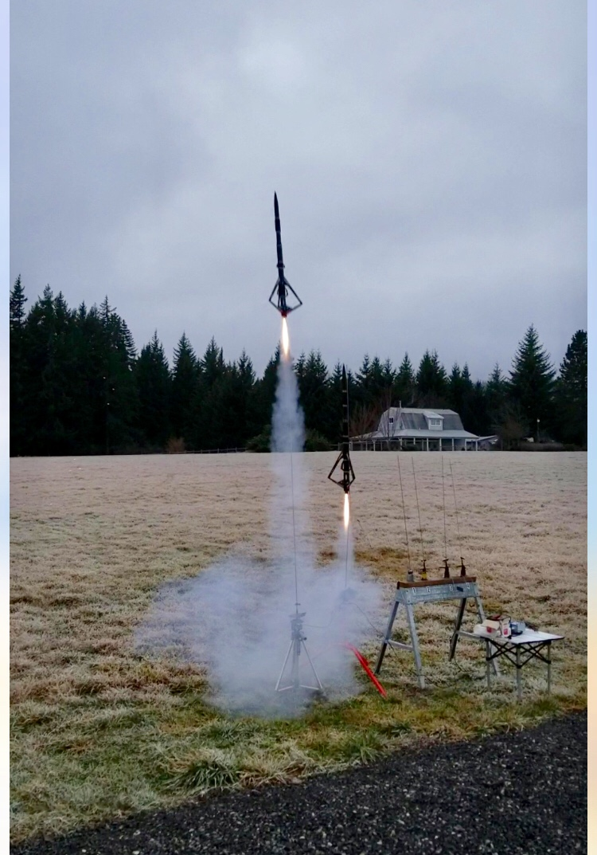Xander is a senior in High school and is doing great with his classes and should be graduating June of 2019. I foresee him working in the technical field of computers as a potential profession after high school.

Work here is plugging away at a steady pace. I did have to make a visit to Ft Bliss during the first week of December in order to return gear back to the Army. The base is pretty nice and I was able to check out some of their museums on the base before returning back to Washington. I will be traveling back to that base at least twice a year probably in 2019.

I hope this letter finds you all well I hope your New Year is a pleasant one. All the best to you!!

R/S

John Thompson